
SHIRE HIGHLANDS EDUCATION DIVISION
2026 MALAWI SCHOOL CERTIFICATE OF EDUCATION MOCK
EXAMINATION

ADDITIONAL MATHEMATIC PI
MARKING KEY
1. Find the coefficient of the middle term in the expansion of (3 - 2x)⁶. (6 marks)
= n(n - 1)(n - 2)/3! x 3³(-2x)³ 1 mrk for the power 3 showing it is the middle term 2 mrks for the method of finding the 20 [see using the factorial method or the Pascal’s triangle method] 1 mrk for the 20 = 20 x 9 x -8x³ 1 mrk for the 8 or 9 = -1440 1 mrk for the correct result
2. A function is such that X Y using the rule f(x) = 4x - 1. Show that f is an onto function. (5 marks)
Let y E Y and x E X Required to prove that for all x is such that f(x) = y 1 mrk for stating the requirement of an onto function y = 4x - 1 $\frac{y + 1}{4}$ = x 1 mrk for making x subject Then f($\frac{y + 1}{4}$)= 4[$\frac{y + 1}{4}$] - 1 1 mrk for substitution into the rule = y + 1 - 1 1 mrk for finding +1, i.e cancelling out the 4s = y 1 mrk for the y
3. a
Log x | 1.18 | 1.26 | 1.29 | 1.40 | 1.48 | 1.52
Log y | 1.42 | 1.52 | 1.59 | 1.75 | 1.87 | 1.93
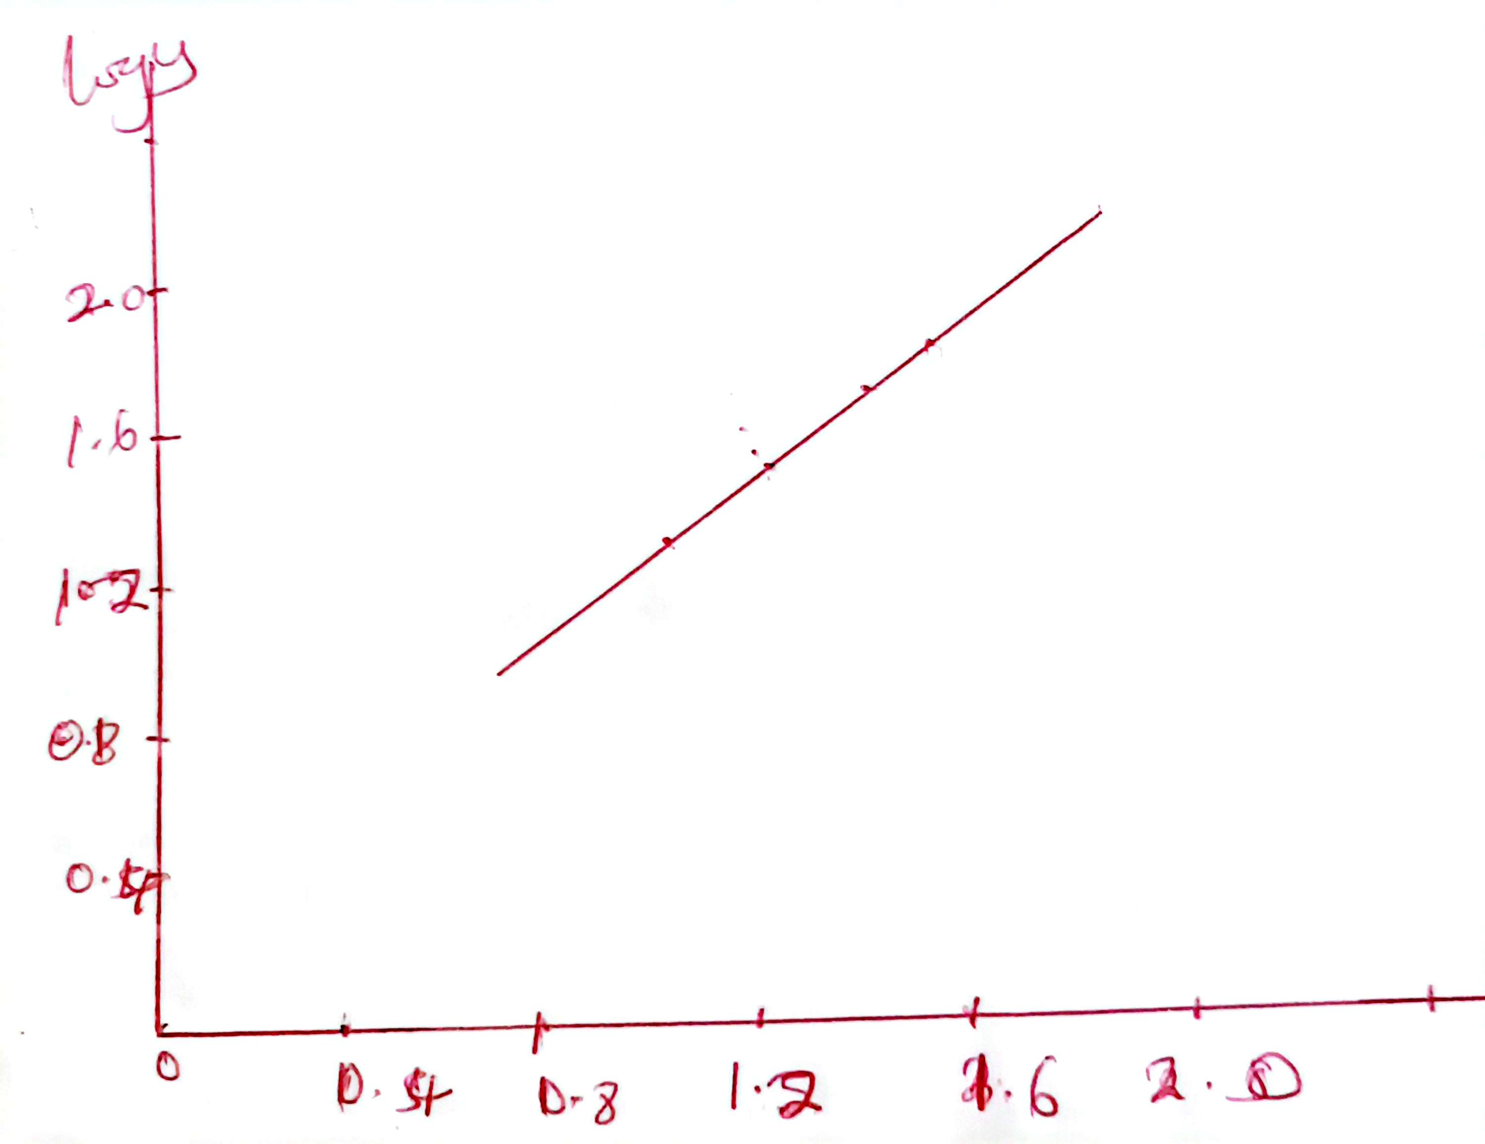
b. 1 mrk for correct x-axis
1 mark for correct y axis
1 mrk for straight line
$$a=\frac{y_{2}-y_{1}}{x_{2}-x_{1}}=\frac{1.87-1.52}{1.48-1.26}=\frac{0.35}{0.22} (1 mark)$$
= 1.59 (1 mark)
4. (a) Figure 1 is a graph of y = sin x. Sketch in the same diagram, the graph of y = sin 2x. (5 marks)
sin Ө
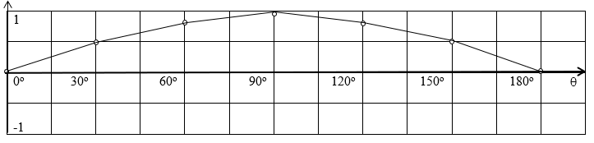

- = y = sin Ө (b) = y = sin 2Ө
Finding Ө for y = sin 2Ө and sin 2Ө x = 45º, 2x = 2x45º =90º then sin 90º = 1 1 mrk for either 90 or 1 x = 90º, 2x = 2x90º = 180º then sin 180º = 0 1 mrk for either 180 or 0 x = 135º, 2x = 2x135º = 270º then sin 270º = -1 1 mrk for either 270 or -1 x = 180º, 2x = 2x180º = 360º then sin 360º = 0 1 mrk for either 360 or 0 1 mrk for the correct smooth graph of y = sin 2x
(b) Given y = 3 - x + 2x² and x is increased from 4 by an amount r/100 where r is small, find in terms of r (i) the approximate change in y , (ii) the percentage change in y. (6 marks) (i) $\frac{dy}{dx}$ = -1 + 4x² 1 mrk - see one term correct and with x = 4, $\frac{dy}{dx}$ = 15 1 mrk for correct result then ẟy = 15 x $\frac{r}{100}$ = $\frac{3r}{20}$ 1 mrk - see the simplified result (it can be 0.15r as well) (ii) The original value of y was 3 - 4 + 2x4² = 3 - 4 + 32 = 31 1 mrk - at least see the 32 or 31 therefore the percentage change in y = $\frac{ẟy}{y}$ x 100% = $\frac{3r}{20 x 31}$ x 100% [or $\frac{0.15r}{ 31}$ x100%] 1 mrk - see dividing by original y or multiplying her value with 100% = $\frac{15r}{31}$ % 1 mrk for the correct result
5. (a) Suppose Q = f(t) is an exponential function of t. If f(20) = 88.2 and f(23) = 91.4 and letting
Q = Q₀a^{t}, (i) find the base , (ii) find the growth rate. (7 marks)
(i) Substituting t = 20, Q = 88.2 and t = 23, Q = 91.4 gives two equations for Q₀ and t 88.2 = Q₀a²⁰ and 91.4 = Q₀a²³ 1 mrk for any one correct substitution 1 mrk for one correct equation Dividing the two equations to eliminate Q₀: $\frac{91.4}{88.2}$ = $\frac{Q_{0}a^{23}}{Q_{0}a^{20}}$ = a³ 1 mrk for correct division - see corresponding values as numerators or denominators 1 mrk for correct result a³ Solving for the base, a, gives a = $\sqrt[3]{\frac{91.4}{88.2}}$ = 1.012 1 mrk for the correct value of a ( ii) Since a = 1.012, the growth rate is 1.012 - 1 = 0.012 1 mrk - see subtracting 1 from her base 0.012 x 100 = 1.2% 1 mrk - see correct value for growth rate
(b) Solve for x in |x - 3| ≤ 2 and sketch your solution on the real line. (6 marks)
Method 1 - |x - 3| ≤ 2 1 mrk for the negative sign + |x - 3| ≤ 2 1 mrk for the addition sign 3 - x ≤ 2 x ≤ 5 1 mrk for the 5 -x ≤ -1 1 mrk for the minus 1 x ≥ 1 1 mrk for reversing the inequality symbol
1 5 x 1 mrk for the correct real line, that is a range with solid dots at the ends
Method 2 Expressing the inequality without absolute value symbols (|x - 3|)² ≤ 2² 1 mrk for squaring both sides to remove the | | symbols (x- 3)(x - 3) - 4 ≤ 0 x² - 6x + 9 - 4 = 0 1 mrk for expanding - see 6 or 9 x² - 6x + 5 = 0 (x - 1)(x - 5) = 0 1 mrk for one pair of bracket correct therefore critical values are x = 1 or 5 1 mrk for one root correct 1 mrk for both roots correct 1 mrk for the correct real line – see in Method 1.
6. (a) Use a table to estimate the limit of $\frac{x^{2}- 9}{x - 3}$ for x values approaching 3 from above. [Use at least seven values of x.] (5 marks)
x | 4 | 3.9 | 3.8 | 3.5 | 3.3 | 3.1 | 3.05
$$\frac{x^{2}- 9}{x - 3}$$ | 7 | 6.9 | 6.8 | 6.5 | 6.3 | 6.1 | 6.05
2 mrks for any three values of x² - 9/x - 3 being correct 2 mrks for all values correct, that is when all the seven are correct award 5 mrks straight! therefore as x approaches 3, the limit is 6 1 mrk for correct result
(b) Evaluate $\int_{0}^{\frac{π}{6}}{\cos^{3}}x$ dx. (6 marks)
= $\int_{0}^{\frac{π}{6}}{{\cos{x (}cos}^{2}}x)$ dx 1 mrk for rewriting cos³ x as shown = $\int_{0}^{\frac{π}{6}}{{\cos{x (1- }sin}^{2}}x)$ dx 1 mrk for using the identity sin² x + cos² x = 1 = $\int_{0}^{\frac{π}{6}}{{\cos{x - }\cos{x }sin}^{2}}x$ dx 1 mrk for expanding
$π/6$ = $\left[\sin{x- \frac{1 }{3} \sin^{3}x}\right]$ 1 mrk for any one correct integral 0 0 = $\frac{1}{2}- \frac{1}{3} x {(\frac{1}{2})}^{3}$ = $\frac{1}{2}$ $─ \frac{1}{24}$ 1 mrk for the 1/24 = $\frac{11}{24}$ 1 mrk for the correct result
7. A spherical balloon is being filled with air at the constant rate of 2 cm³/sec. How fast is the radius
increasing when the radius is 3 cm? (6 marks) volume of sphere = $\frac{4}{3}π$r³ 1 mrk for formula - see 4 multiplying or power 3 $\frac{dV}{dr}$= $\frac{4 x π x 3({r cm)}^{2}}{3}$ 1 mrk for 3r² - see that a candidate is trying to differentiate = 4$π$ r²cm² according to chain rule $\frac{dV}{dr} x \frac{dr}{dt}$ = $\frac{dV}{dt}$ 1 mrk for seeing the LHS is the same as dV/dt substituting the given values into the chain rule 4$π$ r²cm² x ($\frac{dr}{dt}$) = 2cm³/sec 1 mrk for one correct substitution making $\frac{dr}{dt}$ subject: $\frac{dr}{dt}$ = $\frac{2 {cm}^{3}}{4π3^{2}{cm}^{2 }sec}$ 1 mrk - see 4$π$r²cm² or her result dividing into 2 cm³/sec = $\frac{1}{18π}$ cm/sec 1 mrk for correct result with the correct units!
Section B (40 marks) (Solve any two problems in this section)
8. (a) Given the following equation 2x² - 3x - 3 = 0, calculate
(i) the coordinates of the turning point
(ii) the equation of the line of symmetry. (10 marks)
(i) 2x² ─ 3x - 3 = 0 2(x² ─ $\frac{3x}{2}$) ─ 3 = 0 1 mrk for dividing -3x by 2 to normalise the factoring of the 2 (x² ─ $\frac{3x}{2}$) $─$ $\frac{3}{2}$ = $\frac{0}{2}$ 1 mrk for dividing every term by 2 (x² ─ $\frac{3x}{2}$ + $\frac{9}{16})$ ─ $\frac{3}{2}$ ─ $\frac{9}{16}$ = 0 (x ─ $\frac{3}{4}$)² ─ $\frac{(24 + 9)}{16}$ = 0 1 mrk for the single fraction (x - 3/4)² - 33/16 = 0 therefore the coordinates of the turning point are ($\frac{3}{4}$, $\frac{-33}{16}$) 1 mrk for one coordinate correct 1 mrk for both coordinates correct
(ii) the roots of the equation are (x ─ $\frac{3}{4}$)² = $\frac{33}{16}$ 1 mrk for transposing the -33/16 x ─ $\frac{3}{4}$ = $±$ $\sqrt{\frac{33}{16}}$ x = $\frac{3}{4}$ $±$ $\frac{5.7446}{4}$ 1 mrk for square rooting both sides or the RHS only with no power 2 on LHS therefore x₁ = $\frac{3}{4}$ + $\frac{5.7446}{4}$ = $\frac{8.7446}{4}$ = 2.186 x₂ = $\frac{-2.7446}{4}$ = ─ 0.675 1 mrk for one root correct equation of line of symmetry = $\frac{x_{1 }+ x_{2}}{2}$ 1 mrk for the formula = $\frac{2.186-0.675}{2}$ = $\frac{1.511}{2}$ x = 0.76 1 mrk for the correct result

(b) Figure 2 is a circle centre O with a radius of 4 cm. AB is a chord of length 4 cm and divides the
circle into two segments. Find, correct to 2 decimal places, the area of the minor segment. (10 marks)
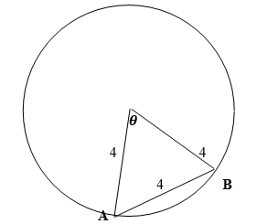
Figure 2 Each side of triangle OAB is 4 cm therefore triangle OAB is equilateral 1 mrk for saying triangle is equilateral hence each angle is 60º 1 mrk for correct angle value area of sector AOB = $\frac{1}{2}$r² Ө 1 mrk for area formula = $\frac{1}{2} x$ 4² x $\frac{1}{3}π$ 1 mrk for any one correct substitution = $\frac{8}{3}π$ 1 mrk for the correct result area of minor segment = area of sector AOB ─ area of triangle OAB = $\frac{8}{3}π$ ─ $\frac{1}{2}$ x(4) x (4) x sin 60º 1 mrk for any one correct substitution into formula for area of triangle OAB = 6.928 1 mrk for correct result of area of a triangle OAB = therefore area of minor seg = $\frac{8}{3}$ $π$ ─ 6.928 1 mrk for subtracting the two areas even if they are wrong = 1.450 1 mrk for correct result of more than 2 dec pl = 1.45 1 mrk for writing her result, even if wrong, to 2 dec pl OR Using Heron's formula A for area of triangle ABC = $\sqrt{[s(s - a)(s - b)(s - c)] }$s = $\frac{a+b+c}{3}$ = $\sqrt{[6(6 - 4)(6 - 4)(6 - 4)] }$ 1 mrk for any one correct substitution = $\sqrt{6 x 2 x 2 x 2}$ The other marks are similar as above! =6.928 therefore area of minor seg = $\frac{8}{3}$ $π$-6.928
= 1.450 = 1.45
9. (a) Solve the following inequality 2x³ + 3x² ─ 8x + 3 ≥ 0 using the graphical method. [shade the region] (12 marks) solving the equation 2x³ + 3x² ─ 8x + 3 = 0
factors of + 3: $-$1, +1, $-$3,+3
2(+1)³ + 3(+1)² - 8(+1) + 3 = 0 1 mrk for attempting to find a factor - see substituting factors of 3 into the polynomial therefore x $-$ 1 is a factor 1 mrk for any correct binomial factor - see change of sign of factor of 3
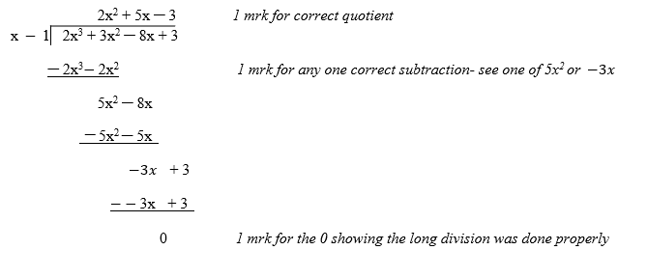 [OR Using synthetic method – see this part in bold This follows after the first 1 mrk Writing down the coefficients
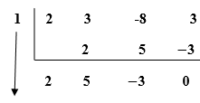
1 mrk for any one of these values
1 mrk for the 0 showing the synthetic method was done properly
(x $-$ 1) ( 2x² + 5x $-$3) 1 mrk for correct binomial factor 1 mrk for the 2x² + 5x $-$3 (x + 1)(2x $- 1$) (x + 3) = 0 1 mrk for factorisation – see one pair of brackets correct therefore the critical values are x₁ = 1 x₂ = $-$3 x₃ = $\frac{1}{2}$ 1 mrk for any one correct root for the graphical solution c = 3 and the critical values are the zero points
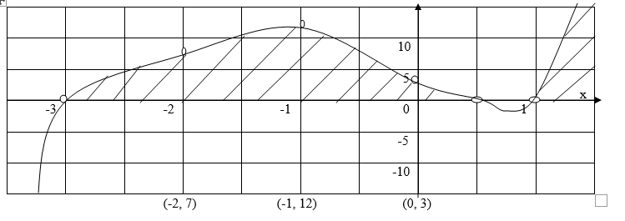
1 mrk for plotting one point other than the y-intercept - see ($+$1,0), ($-$3,0) or ($\frac{1}{2}$,0)
1 mrk for the smooth cubic curve 1 mrk for any one correct shaded region 2 mrk when both regions are shown
1 mrk when correct inequalities obtained
(b) Differentiate f(x) = $\frac{1}{x}$ by first principles. (8 marks) f(x) = $\frac{1}{x}$ f(x + $δ$x) = $\frac{1}{x + δx }$ 1 mrk for coming up with new x - coordinate then f (x + $δ$x) $-$ f(x) = $\frac{1}{x + δx }$ $-$ $\frac{1}{x}$ 1 mrk for subtracting the old value of f(x) from new value = $\frac{x -(x + δx)}{x(x + δx)}$ 1 mrk for trying to express the two fractions as a single fraction = $\frac{- δx}{x(x + δx)}$ 1 mrk for the correct single fraction $\frac{f\left(x + δx\right) - f(x)}{δx}$ = $\frac{- δx}{x\left(x + δx\right)δx}$ 1 mrk for attempting to find the gradient function = $\frac{-1}{x(x + δx)}$ 1 mrk for correct gradient function hence f'’$\lim_{δx → 0}{\frac{-1}{x(x + δx)} }$ 1 mrk for the idea of limit even if her gradient function is wrong = $-$ $\frac{1}{x^{2}}$ 1 mrk for the correct result
10. (a) Prove that (1 $-$ cosA)(1 + sec A) = sinA tanA. (9 marks)
(1 $-$ cosA)(1 + sec A) = 1 + sec A $-$ cos A $-$ cosAsecA 1 mrk for expansion - see any one term correct = 1 + sec A $-$ cos A $-$ cosA x $\frac{1}{cosA}$ 1 mrk for secA = $\frac{1}{cosA}$ = 1 + sec A $-$ cos A $-$ 1 1 mrk for cancelling the two cosAs to get $-$1 = secA $-$ cosA 1 mark for 1 $–$ 1=0
= $\frac{1}{cosA}$ $-$ cosA No mark for secA = $\frac{1}{cosA}$. We do not award 2 mrks for the same skill in a problem! = $\frac{1 - \cos^{2}A}{cosA}$ 1 mrk for sin² x + cos² x = 1 1 mrk for expressing $\frac{1}{cosA}$ $-$ cosA as a single fraction = $\frac{\sin^{2}A}{cosA}$ 1 mrk for substituting sin² A for 1 - cos²A = sinA$\left[\frac{sinA}{cosA}\right]$ 1 mrk for splitting the sin² A as shown = sinAtanA 1 mrk for the correct result
(b) Figure 3 shows two graphs of y₁ = x and y₂ = x² - x intersecting at A and B.
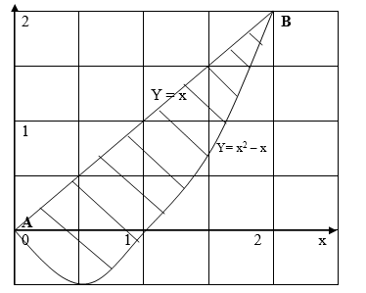

Calculate the area of the shaded part, giving it to 1 decimal place. (11 marks)
$\int{x}$ dx = $\frac{x^{2}}{2}$ + c 1 mrk for integrating x - see power 2 or dividing by 2
1 mrk for the intergration constant c area under y₁ = $\frac{2^{2}}{2}$ $-$ 0 1 mrk for substituting x with 2 = 2 square units 1 mrk for correct area
$\int{(x^{2}- x)}$ dx = $\frac{x^{3}}{3}$ $-$ $\frac{x^{2}}{2}$ + c 1 mrk for integrating x² - x see power 3 or dividing by 3 [the other term was already awarded with 1 mrk above.]
2 area under y₂ = $\left[\frac{x^{3}}{3} - \frac{x^{2}}{2} \right]$ 0 0 = $\frac{8}{3}$ – 2 – 0 1 mrk for the 8 1 mrk for subtracting the 0 = $\frac{(8 - 6)}{3}$ 1 mrk for expressing 8/3 - 2 as a single fraction = $\frac{2}{3}$ square units 1 mrk for correct result of 2/3 {A candidate can use decimal fractions in solving this problem. Listen to her accordingly!} therefore the shaded area = 2 $-$ $\frac{2}{3}$ 1 mrk for the correct subtraction - see area under y = x² - x is subtracted from area under y = x. = (6 - 2)/3 $\frac{(6 - 2)}{3}$ = $\frac{4}{3}$ = 1.33 1 mrk for correct result 1.33

